**INDIA ‘S AGRICULTURE CROP ANALYSIS**

1. **INTRODUCTION**

**1.1 OVERVIEW:**

**Technology based crop recommendation system for agriculture helps the farmer to increase the crop yield by recommending a suitable crop for the land with the help of geographic and the climatic parameters.**

**1.2 PURPOSE**

* **This project focuses on predicting crop yield while using machine learning techniques.**
* **Farmers can use the system to make decisions on what should be grown in the field.**

**2.PROPLEM STATEMENT & DESIGN THINKING**

* **Unreliable rainfall**
* **Lack of irrigation facilities**
* **Soil erosion**
* **Methods of cultivation**
* **Faulty cultivation of crops**
* **Reduction in net sown**

**Solution:**

* **Generating employment opportunities**
* **Reducing risks in agriculture**
* **Developing Agri-infrastructure**
* **Improving quality of rural life**

**2.1 EMPATHY MAP:**

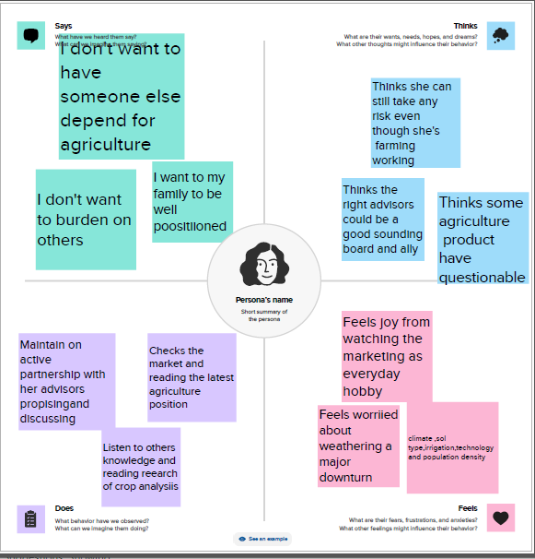

**2.2 Brainstorming map:**

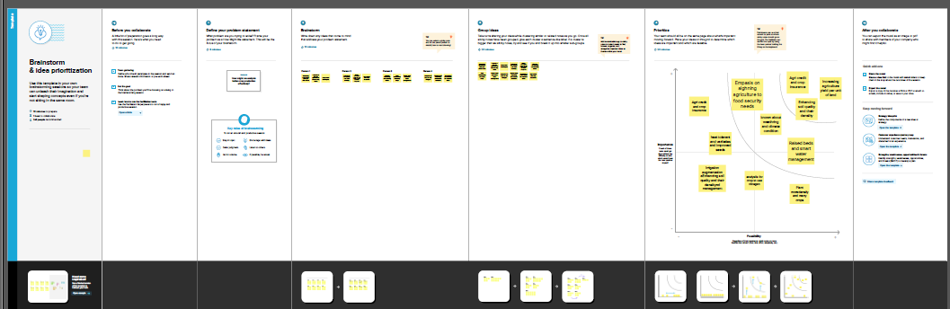

**3.RESULT:**

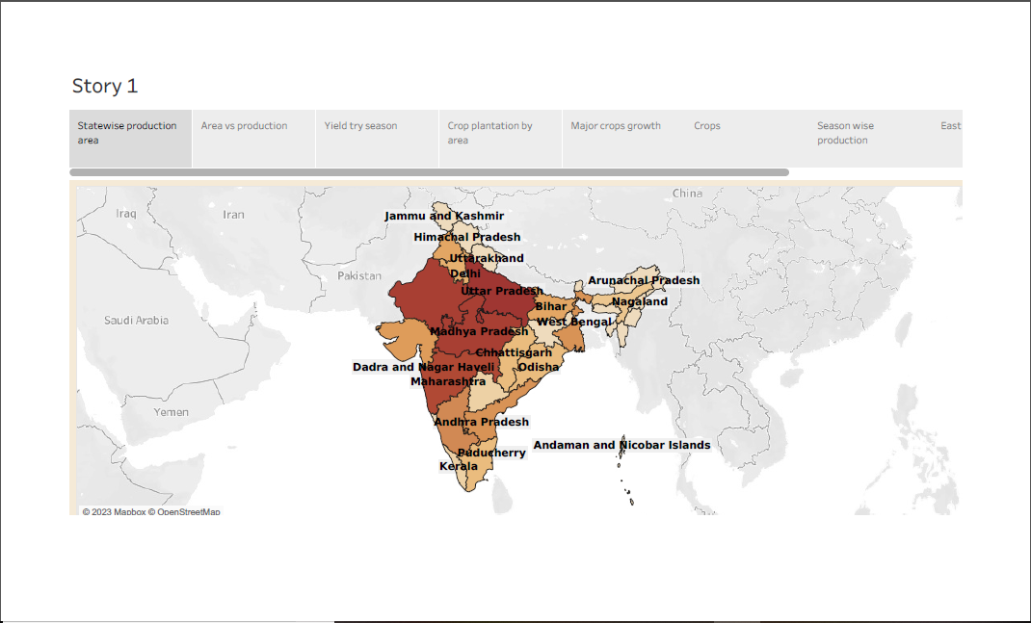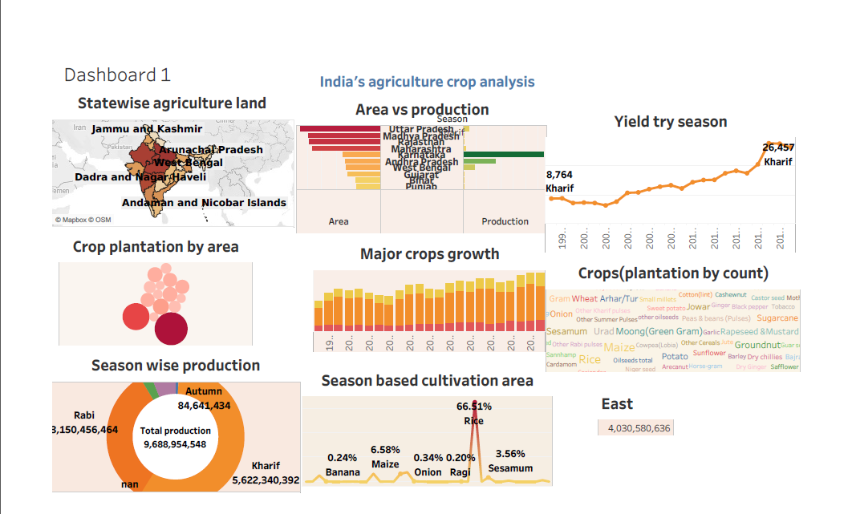

**4.ADVANTAGES:**

* **To increase quality and yields, it is crucial to understand the current nutrient levels of the soil to be able to ascertain which areas require improvement.**

**DISADVANTAGES:**

* **Thes present challenges that plague Indian agriculture are limited knowledge and insufficient infrastructure, especially in the rural areas.**

**5.APPLICATION:**

* **Help ensure the profitability of their land while improving soil fertility, helping promote sound environmental practices, and minimizing environmental impacts through climate action for rural areas.**

**6.CONCLUSION:**

* **This project has oriented by agriculture crop analysis in India. And then we saw that worksheet, dashboard and story pages. In this, we should understand of importance agriculture crop analysis.**

**7.FUTURE SCOPES:**

* **Use nano technology for enhancement method of food quality and safety, efficient of inputs will be in near future.**
* **Nano materials in agriculture will reduce the wastage in use of chemicals, minimize nutrient loses in fertilization and will be used to increase yield through pest and nutrient management.**